Apple iPhone Configuration

Introduction
Automatic configuration of Apple iPhone and iPod touch devices can be automated through the use of a web server and The Apple iPhone Configuration Utility provide by Apple:
http://www.apple.com/support/iphone/enterprise/

To configure Apple iPhones and iPod Touches automatically you must create an XML profile for your sites settings. This profile is then delivered to your client devices using a web server. One method of doing this is to create, or modify an existing captive portal, to recognise the Apple iPhone User Agent string of the browser and then automatically redirect the client device to the XML profile. Alternatively you could place a static link on a web page for Apple iPhone and iPod touch users to click on.

Creating an XML profile
Each institution has different settings and therefore will need its own XML profile. To generate this, on an OSX or Windows PC, visit http://www.apple.com/support/iphone/enterprise/ and download and install the “iPhone Configuration Utility”. After it has finished installing run the application.

- From the ‘Library’ Menu on the left choose ‘Configuration Profiles’ and then Click ‘New’.
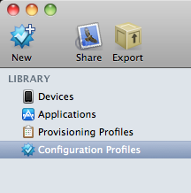

- In the main window select the ‘General’ option on the left. Now fill in the details for your site. 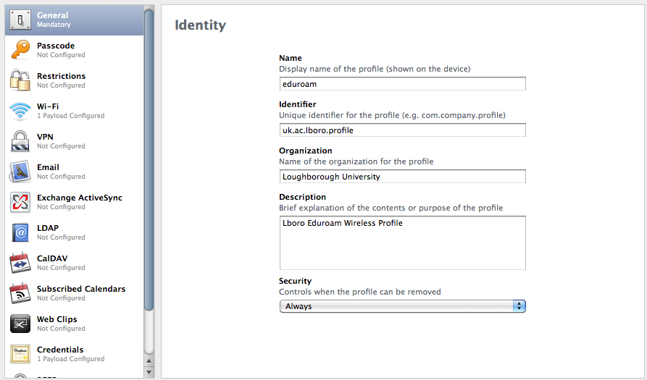
- In the main window area scroll down the list of options and click on ‘Credentials’ and then click ‘Configure’.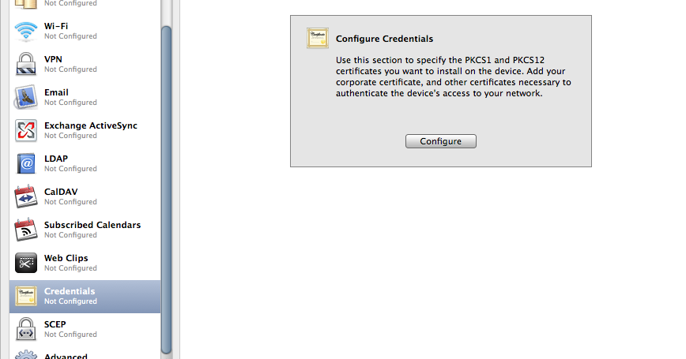

- An ‘Add Credential’ pop-up box will appear. Find and select your Certificate Authority Certificate and click ‘Open’.

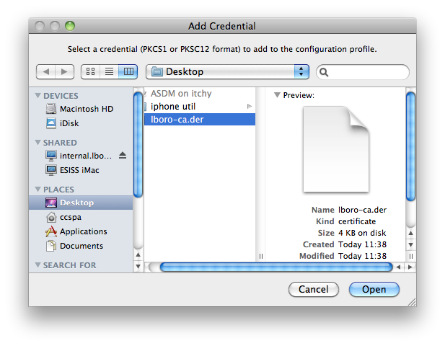
- From the list on the left choose ‘Wi-Fi’ and click ‘Configure Wi-Fi’.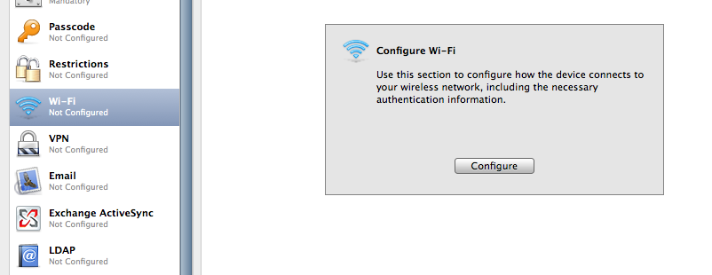

- Enter the SSID, e.g. ‘eduroam’, and then choose ‘WPA/WPA2 Enterprise’ from the ‘Security Type’ drop down box. From the options available choose the authentication for your site, e.g. PEAP.
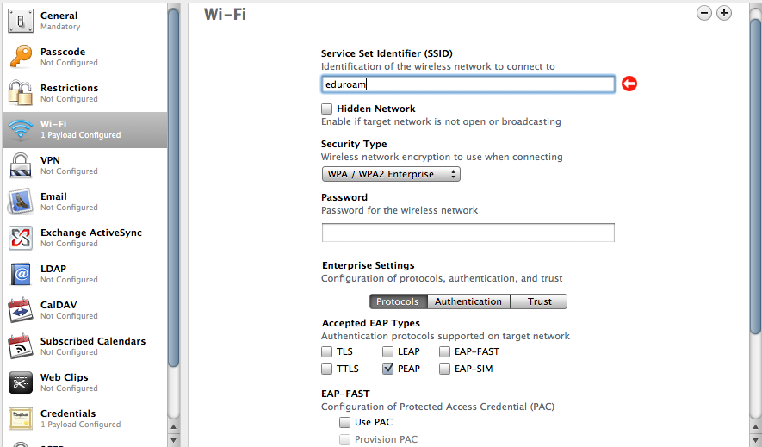

- Select the ‘Authentication’ tab and set your sites ‘Outer Identity’, e.g. anonymous@lboro.ac.uk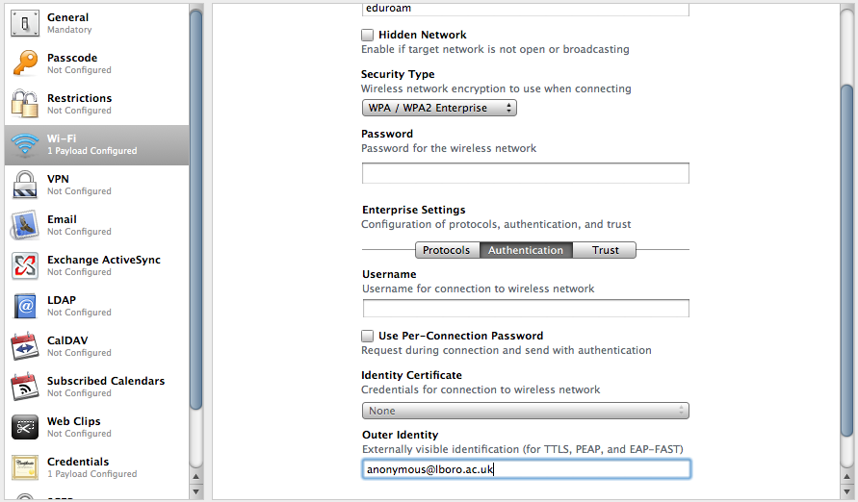

- Select the ‘Trust’ tab and then select your Certificate Authority from the ‘Trusted Certificates’ menu.
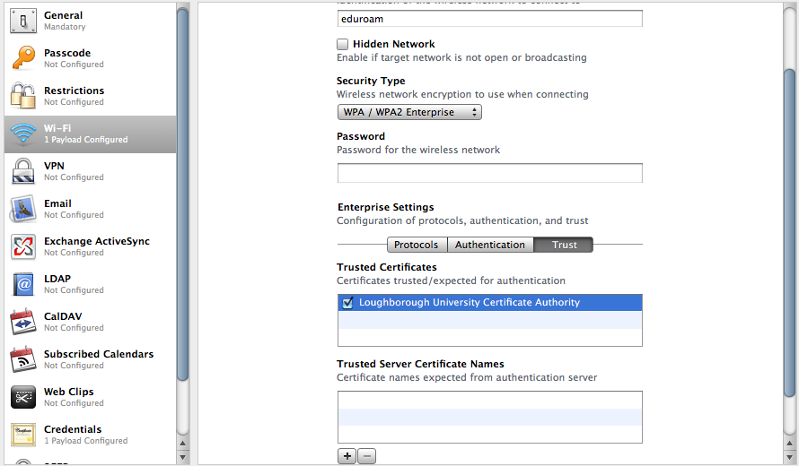

- Click export and choose ‘None’ for the Security and click ‘Export’.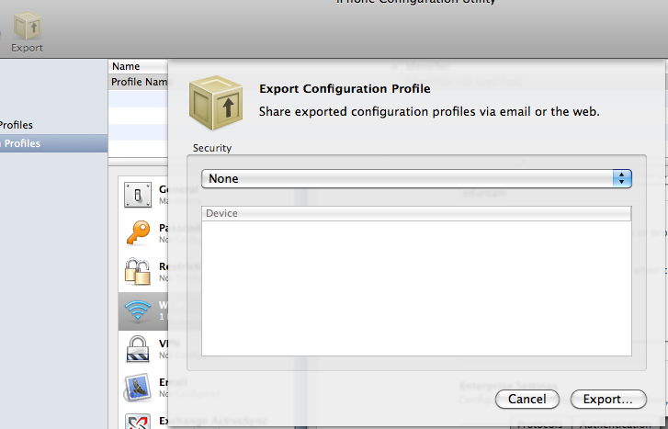
- Name the exported configuration profile eduroam, and click ‘Save’. Then quit the ‘iPhone Configuration Utility’.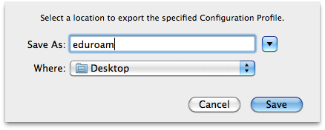

Apache Configuration
The resulting xml file should be put onto a web server so it is accessible to download. E.g. /var/www/mobileconfig/eduroam.mobileconfig

The web servers configuration should now be changed so that iPhone/iPod clients are redirected to download the XML configuration file. On an apache server this can be achieved by editing the httpd.conf (or ssl.conf for secure servers).

First ensure the re-write module is in the LoadModule section, if it isn’t add:

LoadModule rewrite_module modules/mod_rewrite.so
Then in the VirtualHost section for your server add the following rewrite rule:

RewriteEngine On

RewriteCond %{HTTP_USER_AGENT} .*Safari/.*
RewriteCond %{HTTP_USER_AGENT} .*Mobile/.*
RewriteRule /.* /mobileconfig/eduroam.mobileconfig [T=application/xapple-aspen-config]

Client Side
If the redirect is placed on a captive portal network, when the client connects they are automatically redirected to download the xml settings. The user then has to enter their username and password. Once this has been done the profile is saved and the user’s device is configured.

When the client is redirected they will see something similar to the following:

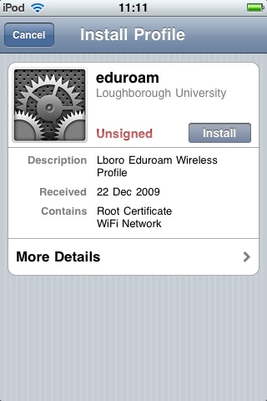

- Click the install button and then click ‘Install Now’.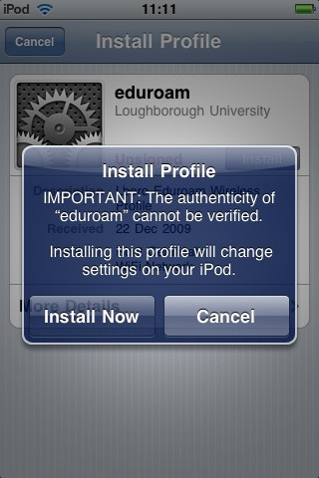
- A prompt will appear asking for a username. The user enters their eduroam username, and then clicks the ‘Next’ button in the top right of the screen.
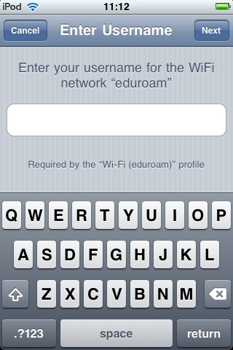
- Next the user enters their password and again clicks the ‘Next’ button.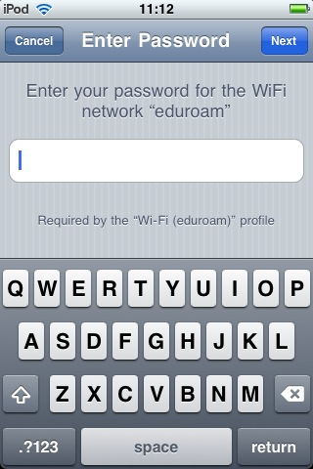
- Once installed a completed screen will appear. The user clicks ‘Done’ to be returned to their home screen.